 | Reg. No:  SRI RAMAKRISHNA ENGINEERING COLLEGE,COIMBATORE  Regulation- 2020 (PC)  (Autonomous Institution, Reaccredited by NAAC with ‘A+’ GRADE Approved by AICTE and Permanently affiliated to Anna University, Chennai)  AUTONOMOUS EXAMINATIONS – MAY/JUNE'2022
B.E - COMPUTER SCIENCE AND ENGINEERING
20CS211 - ALGORITHMS AND COMPLEXITY-II
Answer ALL questions
Duration: 3 Hours |  |  |  | Maximum: 100 Marks
 |  |  |  |  |  |  | PART - A |  |  |  | (7x 1 = 7 Marks)
1. | CO2 | ___________ is the Time complexity of Fake coin identification.
 |  | a) W(n/2) + 2 |  |  |  |  |  | b) W(n/2) |  | c) W(n/2) + 1 |  |  | d) W(n/2) + n
2. | CO2 | Which of the following is the efficiency of the searching problem using transform-and-conquer algorithm design technique?
 |  | a) (n² ) |  |  |  |  |  | b) (n ) |  | c) (nlogn ) |  |  | d) (logn )
3. | CO2 | Articulation points of a graph can be identified by ______ edges.
 |  | a) Forward |  |  |  |  |  | b) Tree |  | c) Backward |  |  | d) Cross
4. | CO1 | Which type of graph is not suitable for Topological Sorting?
 |  | a) DAG |  |  |  | b) Weighted graph |  |  | c) Unweighted graph |  |  |  | d) Cyclic Graph
5. | CO3 | A _________ algorithm have better performance ratio towards approximation on Travelling salesman problem.
a) Nearest Neighbour b) Christofides method
c) Multifragment Heuristics approach d) MST approach

6. | CO1 | Choose the correct 2-3 tree structure for the list 5, 6, 8, 3, 2, 4, 7.
a) 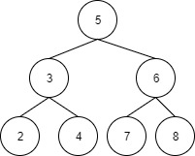 b) 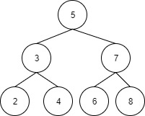
c) 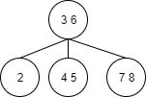 d) 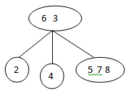

7. | CO1 | Which of the following is false in the case of a spanning tree of a graph G?
a) It is tree that spans G b) It is a subgraph of the G
c) It includes every vertex of the G d) It can be either cyclic or acyclic
Fill in the blanks: |  |  |  |  |  |  |  |  |  |  |  | (3x 1 = 3 Marks)
8. | CO2 | An example for Best first Branch and Bound is ________.
9. | CO3 | _________ is known as Nondeterministic stage.
10. | CO2 | _____ & _______ are the requirements of Interpolation search.
 |  |  |  |  | PART - B |  |  |  |  |  |  | (5x 3 = 15 Marks)
11. | CO2 | At what situations, a search path at the current node in a state space tree of a branch and bound algorithm gets terminated?
12. | CO2 | Evaluate the polynomial P(x) = 5x⁴ + 3x³ – 2x² + 6x – 7 at (x = 5) using Horner’s Rule.
13. | CO2 | State the three variations of Transform and Conquer Techniques.
14. | CO2 | Compute 68 x 87 using Russian Peasent method.
15. | CO3 | Define NP-Clique.
 |  |  |  |  |  |  | PART - C |  |  |  | (5 x 15 = 75 Marks)
Q.No: 16 Compulsory Question
Q.No: 17 to 22 Answer any FOUR Questions
Compulsory Question:
16. | CO1 | i) | Apply the DFS-based algorithm with start vertex as ‘d’ and Source Removal Algorithm to solve the topological sorting problem for the following digraph.  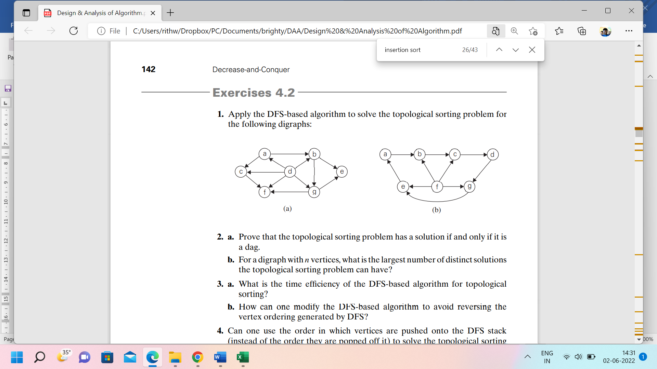 |  |  |  |  |  |  |  |  |  |  | (10)
 | CO2 | ii) | Explain decrease by a constant method with an example. |  |  |  |  |  |  |  |  |  |  | (5)
17. | CO2 | i) | Apply Single source shortest path algorithm to find a minimum spanning tree of the following graph with start vertex as ‘a’.  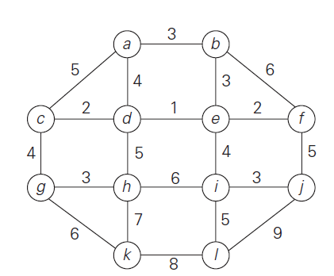 |  |  |  |  |  |  |  |  |  |  | (10)
 | CO2 | ii) | Apply backtracking to the problem of finding a Hamiltonian circuit in the  following graph.  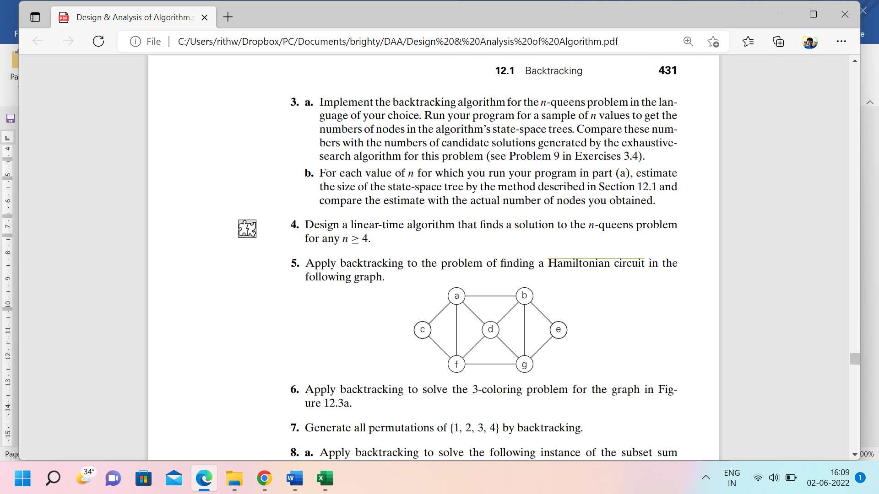 |  |  |  |  |  |  |  |  |  |  | (5)
18. | CO2 | i) | Construct a Huffman code for the following data:  Character A B C D -  Probability 0.35 0.1 0.2 0.2 0.15  Find the code word of each character by constructing tree. |  |  |  |  |  |  |  |  |  |  | (10)
 | CO2 | ii) | Apply the Breadth First Traversal algorithm for the given graph and give the BFS traversal ordering.  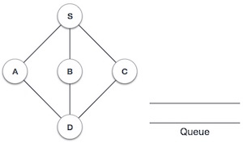 |  |  |  |  |  |  |  |  |  |  | (5)
19. | CO1 |  | Implement the routine to insert elements into an AVL tree and show the result of inserting the following keys 5,6,8,3,2,4,7 with necessary rotations and delete the root element. |  |  |  |  |  |  |  |  |  |  | (15)
20. | CO2 | i) | Apply heap sort using array representation for the list 2,9,7,6,5,8 in Max heap order. |  |  |  |  |  |  |  |  |  |  | (10)
 | CO2 | ii) | Write an algorithm to sort elements using Heap sort technique. |  |  |  |  |  |  |  |  |  |  | (5)
21. | CO3 |  | Explain in Detail about the following using approximation algorithms.  - Nearest Neighbour Algorithm  - Multifragment Heuristic Algorithm.  - Minimum Spanning tree based Algorithm. |  |  |  |  |  |  |  |  |  |  | (15)
22. | CO3 | i) | Find the number of Cliques formed from the 3-CNF-SAT based on  Ø = C1 Λ C2 Λ C3;  C1=(x1 V V )  C2=( V x2 V x3)  C3=( x1 V x2 V x3) and Reduce the Clique into Vertex Cover model for the below graph.  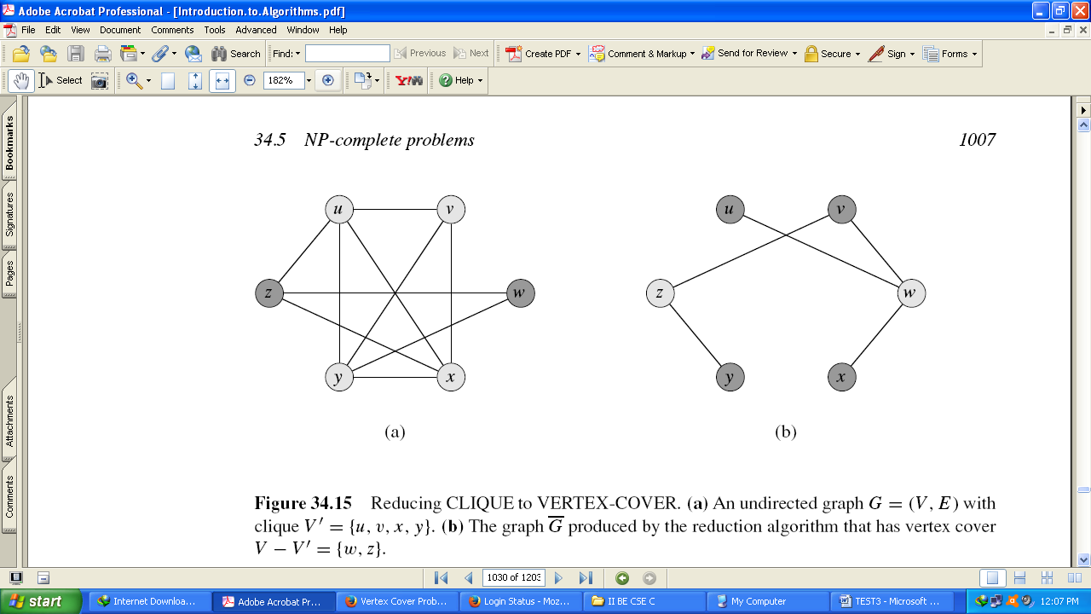 |  |  |  |  |  |  |  |  |  |  | (10)
 | CO3 | ii) | Explain the vertex cover problem with an example. |  |  |  |  |  |  |  |  |  |  | (5)
*****

